NEW PLYMOUTH ADVENTIST CHRISTIAN SCHOOL
Stationery
Senior Class 2022
Books
All books need to be clearly named
MATHEMATICS
1x Mathematics book
Warwick My Maths Book 2
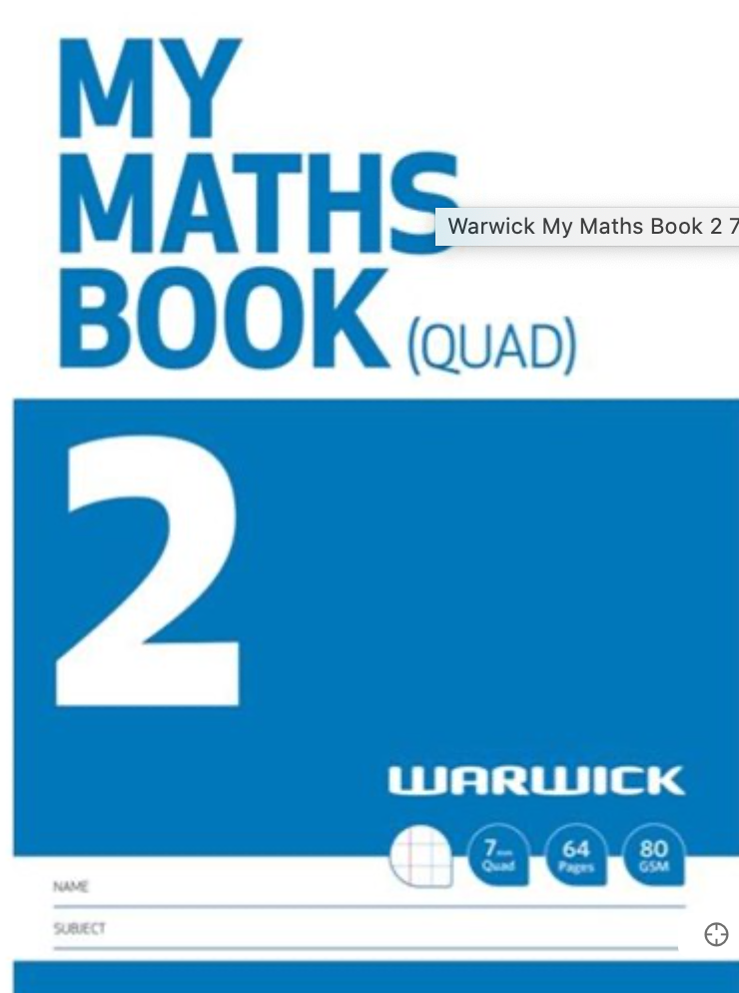

READING / WRITING / THEME & BIBLE / SPARE

4x Literacy Book
Warwick My Literacy Book 3 7mm Ruled 64 Pages

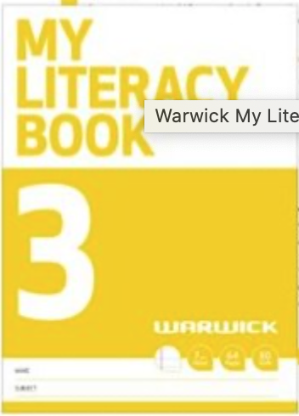

HOMEWORK BOOK

OfficeMax WA4 Writing Exercise Book 7mm Ruled 36 Leaves

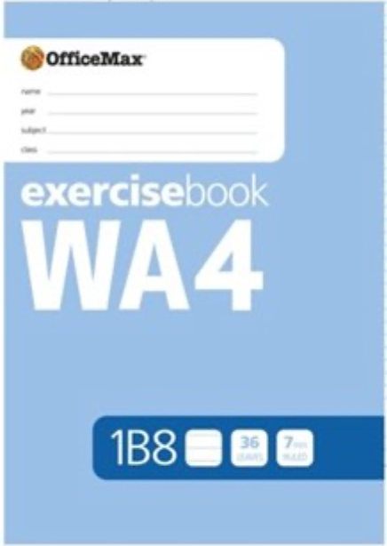

VISUAL/CREATIVE EXPRESSION

OfficeMax UA4 A4 Unruled Exercise Book 36 Leaves

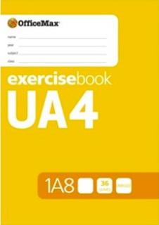
STATIONERY
All stationery needs to be clearly named
- 4 x blue pens
- 2 x red pens
- 5 x pencils
- 1 x vivid
- 1 x pencil sharpener
- 1x eraser
- 1 x green highlighter
- 4 x glue sticks
- 1 x ruler
- 1 x scissors
- Own pencil case
- Headphones (not to be shared)

Shared resources - not to be labelled
- Box of tissues
- Ream of A4 photocopier paper

Optional: Colouring pencils/ felt tips/ gel pens etc.
PURCHASE THROUGH THE OFFICE:

Pr1me Maths Book - $12

Start Right Workbook - $15

