NEW PLYMOUTH ADVENTIST CHRISTIAN SCHOOL
Stationery Senior Class 2020
YEAR 4-5
Books

All books need to be clearly labelled
MATHEMATICS

1x Maths Book (Year 4-5)

Warwick My Maths Book 1 10mm Quad 64 Pages ($2.60)
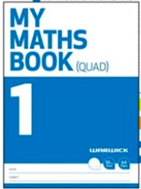

READING / WRITING /CREATIVE WRITING/ THEME/ BIBLE

5x Literacy Book

Warwick My Literacy Book 3 7mm Ruled 64 Pages (4x@2.70=$13.50)
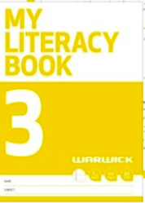

HOMEWORK BOOK

OfficeMax WA4 Writing Exercise Book 7mm Ruled 36 Leaves ($1.87)
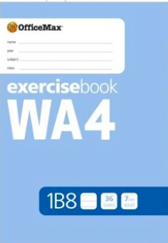
VISUAL / CREATIVE EXPRESSION

OfficeMax UA4 A4 Unruled Exercise Book 36 Leaves ($1.87)
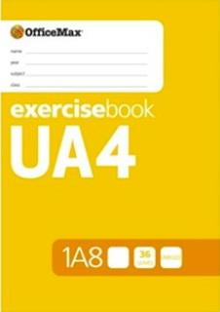
STATIONERY
All stationery needs to be clearly labelled
- 4 x blue pens
- 2 x red pens
- 5 x pencil
- 4 x whiteboard markers (black/blue/green)
- 1 x vivid
- 1 x pencil sharpener/ rubber
- 2 x green highlighters
- 4 x glue sticks
- 1 x ruler
- 1 x scissors
- Box of tissues
- Own pencil case

Optional: Colouring pencils/ felt tips/ gel pens etc.

