NEW PLYMOUTH ADVENTIST CHRISTIAN SCHOOL
Stationery Junior Class 2020
YEAR 2-3
Books
All books need to be clearly labelled
MATHEMATICS
1x Clever Kiwi Fun Doing Maths Exercise Book 1 Up to Year 4
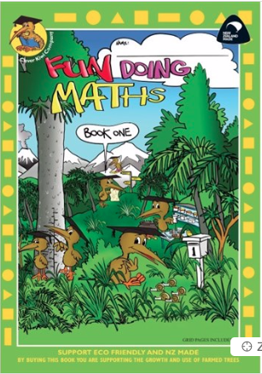
WORD WORK, BIBLE, THEME
3 x Clever Kiwi Activities Book Blank 100gsm 34 Leaves
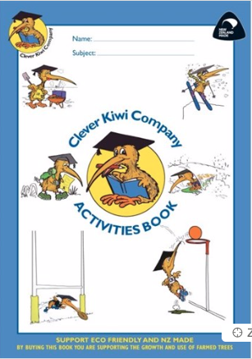
WRITING
1x WS Middle Literacy 2 (Warehouse stationery)
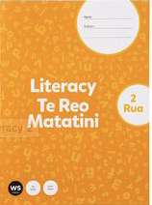

HANDWRITING
1x Clever Kiwi How to Write Exercise Book
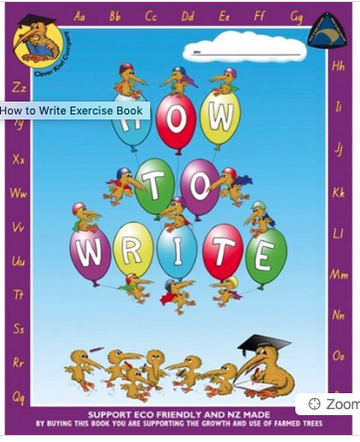
HOMEWORK
1x 1F4
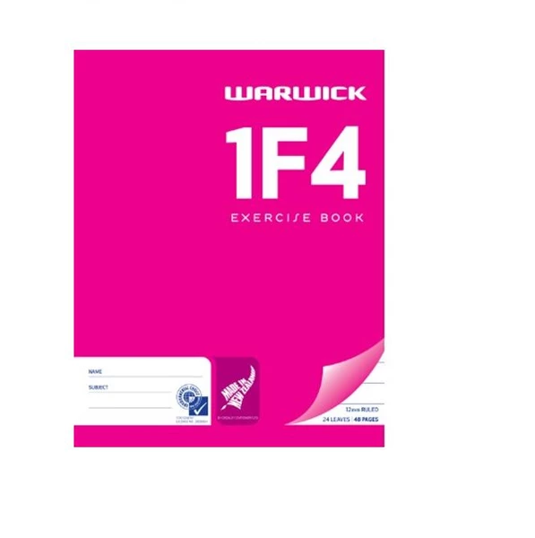
STATIONERY
The following equipment will be shared in the classroom throughout the year therefore it does not need to be named.
- 4x Blue Pens
- 4x grey lead Pencils
- 1 Eraser
- 1 Ruler
- 4x White Board Markers
- 4x Glue Sticks
- 1 Box of tissues
- 1 Pencil Sharpener
- Home learning book bag (reading folder)

